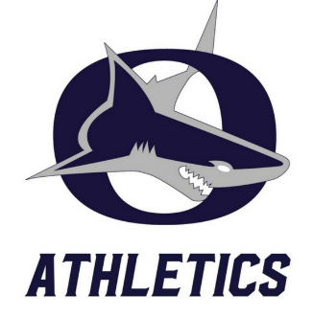
Oasis Sharks Athletic Programs
Contact Athletic Director Michael O’Brien (Coach OB) for coaches contact information michael.obrien@capecharterschools.org 239-541-1167 Ext. 7451
Fall
John.Ferrara@capecharterschools.org
krissy@south41bingo.com
Bowling- Coaches Krissy Stewart & John Ferrara

Cheerleading- Coach Andrea Velasco
andrea.velasco@capecharterschools.org

andrew.salyer@capecharterschools.org
maggie.reading@capecharterschools.org
Cross Country- Coach Andrew Salyer

Football- Coach Jason Grain
jason.grain@capecharterschools.org
Golf- Coach Ken Fritz
ohssharks@gmail.com
Swim- Coach Ed Collins
SwimCoachCollins@gmail.com
Volleyball- Coach Mindy Eichelberger
mindymarlin1@gmail.com

Winter
Girls Basketball- Sam Wood
sam.wood@oasishs.org
Boys Basketball- Marcus Jones
MJBBall3@yahoo.com
Wrestling- Pat Missaoui
Patrick.missaoui@capecharterschools.org
Girls Wrestling- Pam Hull
southwesyselfdefense@gmail.com
Girls Soccer- Jason Duhaime
jason.duhaime@capecharterschools.org
Boys Soccer- Uri Sankowski
urisankowski1@gmail.com

Spring
Baseball- Frank Haba
Frank.Haba@capecharterschools.org
Softball- Josh Shugars
jshug34@gmail.com
Boys Tennis- Curt Berger
BergerCE@yahoo.com
Girls Tennis- Mike Settle
Mike.Settle@capecharterschools.org
Track & Field
Jason Grain
Jason.grain@capecharterschools.org

Contact Athletic Director Michael O’Brien (Coach OB) for more information michael.obrien@capecharterschools.org 239-541-1167 Ext. 7451

