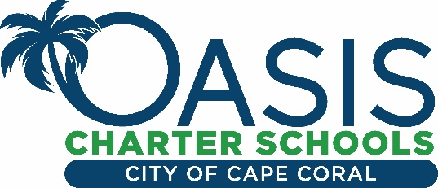

March 31, 2020

Dear Oasis families,

The Florida Department of Education has advised districts throughout the state to extend school closures until May 1st. Therefore, the Oasis school system will remain closed as we follow the guidance of the School District of Lee County. Additional closures will be communicated prior to May 1st and we will forward that information to you.

The USDA has authorized the State of Florida to waive the requirement for children to be present during meal pick-up. Parents/guardians will now be able to pick up meals and take them home to their children. For information regarding the District’s, Grab & Go Meal locations, and additional resources for families, please visit https://www.leeschools.net/distance_learning.

I am proud of our staff as they are working very hard to create innovative on- line lessons that are engaging for our students. Please be patient with us as we work our way through this first week of virtual learning. Our goal is to make sure we educate at the same level of expectation, yet we do not overwhelm students and families. We will proactively examine how we are rolling out lessons each week. Our goal is to make sure everyone is learning appropriately and is remaining healthy. If you have additional questions or needs, please contact your child’s teacher or principal or me at any time.

Sincerely,

Jacquelin Collins
Superintendent

